PKI (Public key infrastructure)

1. How a Website Gets a Certificate from a CA

Step 1: Website Owner Generates Keys
The website owner creates:
- Public Key
- Private Key
using algorithms like RSA cryptosystem.
The private key stays secret on the server.

Step 2: Create CSR (Certificate Signing Request)
The website owner creates a CSR containing:
- Domain name (example.com)
- Public key
- Company/owner information
This CSR is sent to a CA like DigiCert.

Step 3: CA Verifies Ownership
The Certificate Authority must confirm you own the domain.
They verify using methods like:
1. Email verification
Send an email to domain owner.
2. DNS verification
You add a special record in DNS.
3. File verification
Upload a verification file to the website.
Example for example.com:
http://example.com/.well-known/verification.txt
If verification succeeds ✅
The CA proceeds.

Step 4: CA Signs the Certificate
The CA creates a digital certificate and signs it using its private key.
This creates a trusted Digital Certificate.
The certificate includes:
- Domain name
- Public key
- Issuing CA
- Expiry date
- CA digital signature

Step 5: Website Installs the Certificate
The website owner installs the certificate on their web server.
Example servers:
- Apache HTTP Server
- Nginx
- Microsoft IIS
Now the website can run HTTPS securely.

netdiscover – r <target_ip>
Step 1: Website Owner Generates Keys

2. Why Browsers Trust the Certificate
Browsers already contain root certificates from trusted CAs.
So when the server sends a certificate:
Browser checks:
- CA signature
- Domain name match
- Expiration date
- Certificate chain
If all are correct → 🔒 Secure connection

✅ Simple summary of PKI
Website owner → creates CSR → sends to CA → CA verifies domain → CA signs certificate → website installs certificate → browser trusts it.

TLS (Transport Layer Security)

1. TLS Handshake
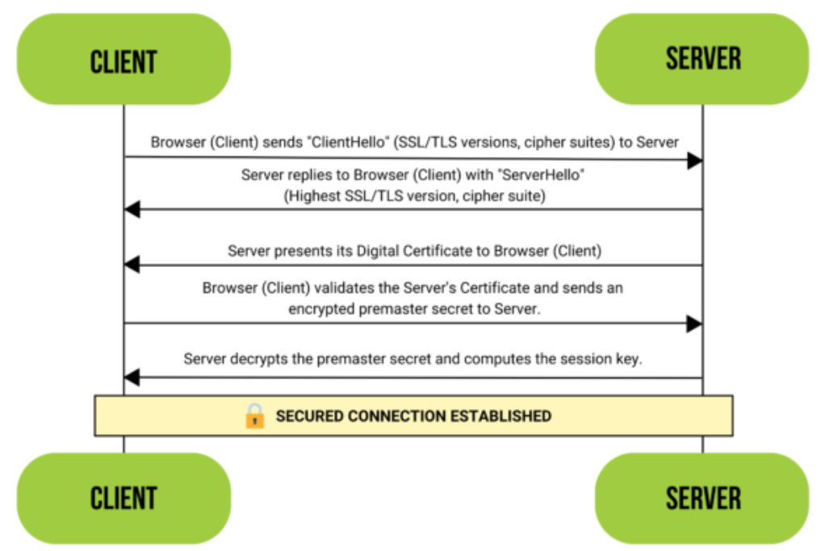
Reference : https://www.ssl.com/article/ssl-tls-handshake-ensuring-secure-online-interactions/

Packet / Step | Contents / Purpose
ClientHello | Supported TLS versions, cipher suites, client random, ephemeral key (KeyShare)
ServerHello | Chosen cipher, server random, ephemeral key (KeyShare)
Certificate | Server’s X.509 certificate signed by CA → PKI verification
KeyShare Messages | Ephemeral public keys → used to derive symmetric session key
Finished Messages | Encrypted handshake verification using session key
Application Data | Encrypted data using symmetric key (AES-GCM, ChaCha20)

